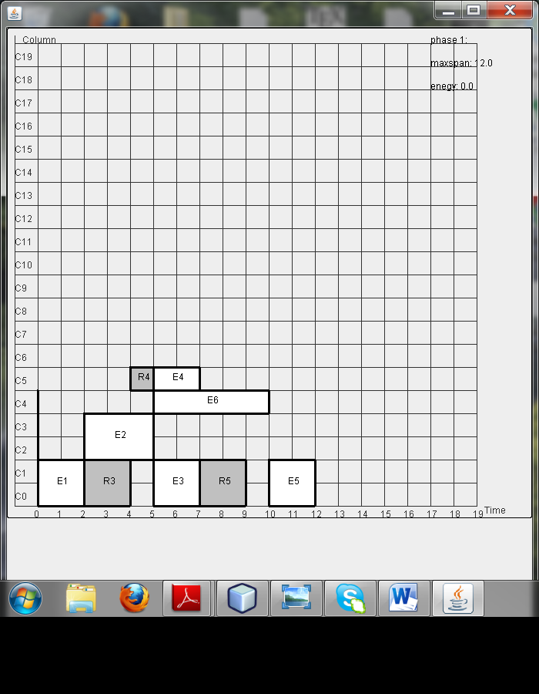

Exmaple 1- with leakage aware placement lk=0, est=10 (est>>lk)

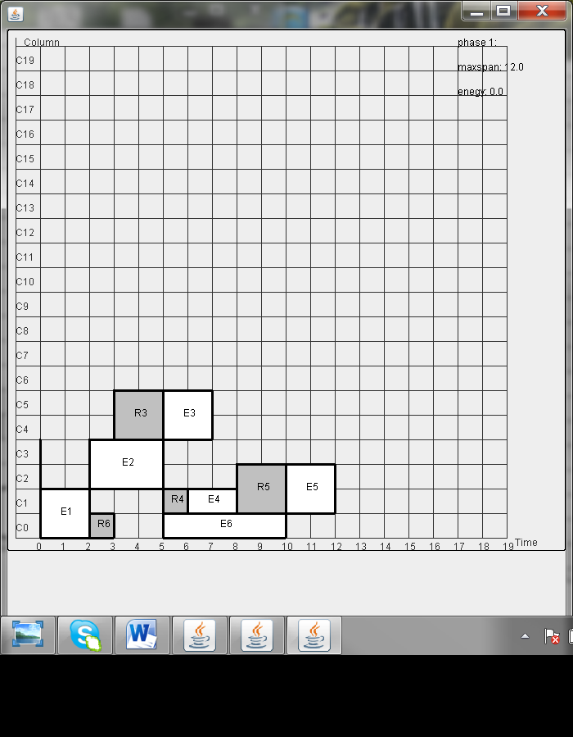

Exmaple 1- with leakage aware placement lk=20, est>10 (est>=0.5\*lk)

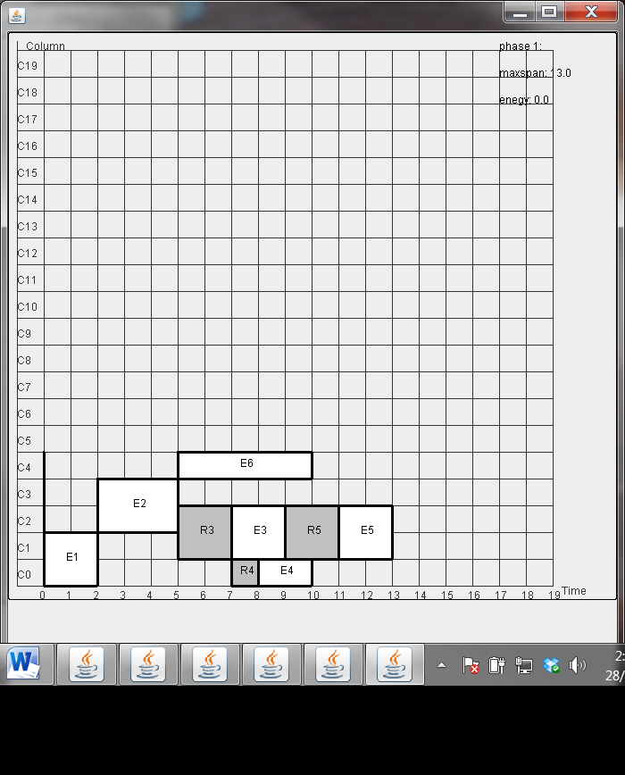

Exmaple 1- with leakage aware placement lk=20, est=3,1-9 (est<o.5\*lk)

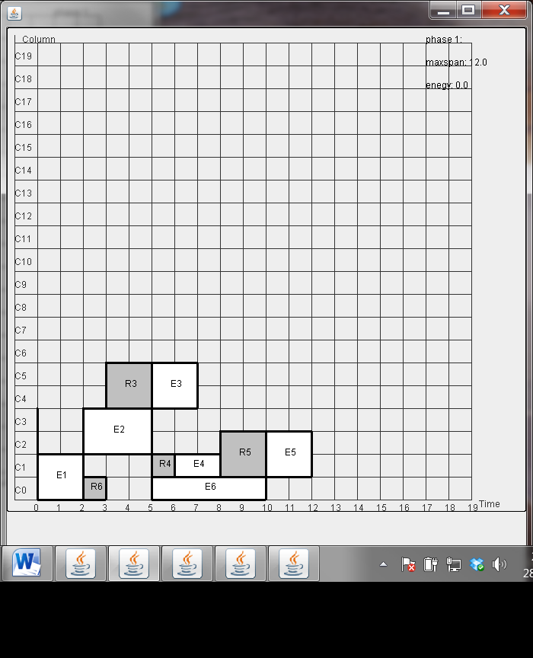

Exmaple 1- with leakage aware placement lk=20, est=2 (???)

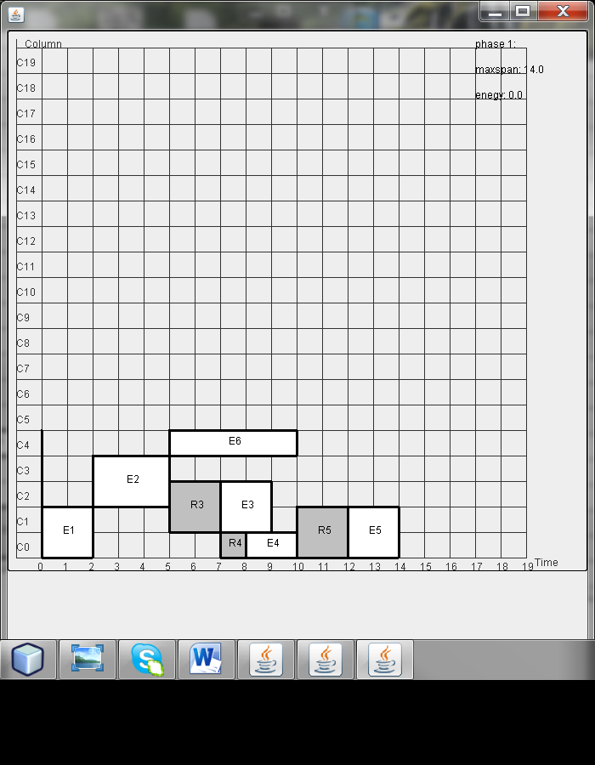

Exmaple 1- with leakage aware placement lk=20, est=0 (est<<lk

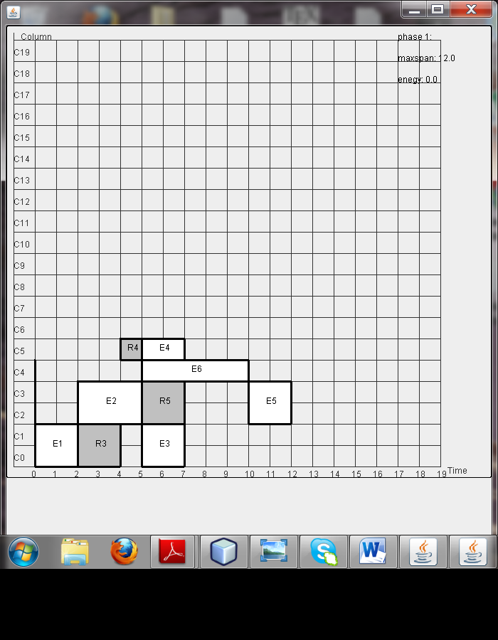)

Exmaple 1- without leakage aware placement